TECHNICAL MANUAL

ECO R290 RANGE

MODELS:

**ECO 25**

**ECO 35**

**ECO 45**

**ECO 60**

**ECO 80**

**ECO 120**

**READ THIS MANUAL CAREFULLY, ESPECIALLY THE INSTALLATION AND MAINTENANCE SECTIONS. THE INSTALLATION OF THIS APPLIANCE MUST BE CARRIED OUT BY THE TECHNICAL ASSISTANCE SERVICE.**

**INDEX**

1. INTRODUCTION 4

1.1 WARNINGS 4

1.2. MACHINE RECEPTION 7

2. INSTALLATION 8

2.1. LOCATION OF THE ICE MACHINE 8

2.2. ICE MACHINE LEVELING 9

2.4. MINIMUM DISTANCE TO OBSTACLES 10

2.5. WATER SUPPLY CONNECTION 11

2.6. DRAIN CONNECTION 12

2.6.1. GRAVITY DRAINAGE 12

2.6.2. DRAIN FORCE CONNECTION 12

2.7. ELECTRIC CONNECTION 13

3.1. PRIOR CHECK 14

3.2. START UP 15

4. COMPONENTS DESCRIPTION 16

4.1 REFRIGERATION DIAGRAM 16

4.2 HYDRAULIC EQUIPMENT 17

4.3 ELECTRICAL EQUIPMENT 18

4.4. CONTROL BOARD 19

4.4.1 PCB CONNECTIONS 19

4.4.2 LED SIGNALLING: INPUTS 19

4.4.3 LED SIGNALLING: OUTPUTS 20

4.4.4 SIGNALLING LEDs 20

4.4.4 DIP SWITCHES SETTING 21

4.4.5 FUNCTIONS OF THE INTERNAL BUTTON ON THE PCB 22

4.4.6 DRAIN FORCE CONTROL BOARD 23

5. SEQUENCE OF OPERATION 24

5.1.- SEQUENCE OF OPERATION 25

6- ALARMS 27

6.1 SAFETY HIGH PRESSURE SWITCH / THERMAL PROTECTOR 27

6.2 LONG HARVEST 27

6.3 ICE PRODUCTION CYCLE TIMEOUT 27

6.4. FAULTY TEMPERATURE PROBE 27

7. MAINTENANCE AND CLEANING PROCEDURES 28

7.1 CLEANING OF AIR CONDENSER 29

7.2 CLEANING THE WATER CONDENSER 29

7.3 CLEANING WATER DISTRIBUTOR AND INJECTORS 30

7.4 CLEANING THE ICE BIN AND EXTERIOR 31

7.5 WATER LEAKAGE CHECKING 31

7.6 CLEANING THE HYDRAULIC SYSTEM 31

7.7 MAINTEANCE TABLE 33

8.1 GENERAL QUESTIONS 34

8.2 PUMP DRAINAGE 35

9. TECHNICAL INFORMATION 35

WIRING DIAGRAM **¡Error! Marcador no definido.**

# INTRODUCTION

This manual has been created to provide the installer with information to carry out a correct installation and for the effective maintenance of the machine.

Furthermore, the user will find in the document a section referring to the cause of possible incidents, as well as complete information on their resolution.

Therefore, it is recommended to keep the manual in a safe place to resolve any questions related to the operation of the machine during its useful life.

## 1.1 WARNINGS

* The installation of this equipment must be carried out by the Technical Service.
* Connect only to a drinking water distribution network.
* Use the new hoses supplied with the appliance. Old hoses must not be reused.
* The socket must always be located in an accessible place.
* When positioning the appliance, make sure that the power cord is not trapped or damaged.
* Do not place multiple portable power outlets or portable power sources at the rear of the appliance.
* Always disconnect power to the machine before any cleaning or maintenance service.
* Any necessary change in the electrical installation for the proper connection of the machine must be carried out exclusively by qualified and certified professional personnel.
* Modifying or attempting to modify this machine is extremely dangerous and will void the warranty.
* The appliance must not be used by persons (including children) with reduced physical, sensory or mental capabilities, or lack of experience and knowledge, unless they have been given supervision or instruction.
* Connect only to potable water supply. This machine is not intended to be used outdoors or exposed to rain.
* The machine must be connected using the power cord supplied with the equipment. It is not intended to be connected to a fixed pipeline.
* To avoid danger due to instability of the appliance, it must be fixed in accordance with the instructions.

If the power cable is damaged, it must be replaced with a special mounting cable that will be supplied by the manufacturer or after-sales service. This replacement must be carried out only by a qualified technical service.

It is mandatory to connect the equipment to ground to avoid possible electric shocks to people or damage to the equipment. The machine must be grounded in accordance with local and/or national regulations. The manufacturer disclaims any responsibility in the event of damage occurring due to the lack of ground installation.

To ensure the proper functioning and efficiency of this equipment, it is very important to follow the manufacturer's recommendations, especially those related to cleaning and maintenance operations, which must only be carried out by qualified personnel.

**ATTENTION:** The intervention of unqualified personnel, in addition to being dangerous, can cause serious breakdowns. In case of damage, contact your dealer. We recommend always using original spare parts.

The Company reserves the right to make changes to specifications and design without notice.

**WE REMIND YOU THAT MAINTENANCE AND CLEANING OPERATIONS ARE NOT INCLUDED IN THE WARRANTY AND THEREFORE, THEY WILL BE BILLED BY THE INSTALLER.**

This sign indicates "Risk of Fire/Flammable Materials" due to the use of flammable refrigerant.

For this reason, the following warnings should be considered:

* Keep the openings for ventilation of the appliance casing or built-in furniture without obstructing it.
* Do not use mechanical devices or other means to accelerate defrosting, only those recommended by the manufacturer.
* Do not damage the refrigerant circuit.
* Do not use electrical devices inside the food compartments, unless they are recommended by the manufacturer.
* Explosive substances, such as aerosols with flammable propellant, must not be stored in this appliance.

In case of refrigerant leak:

* Do not generate a flame in the surroundings of the appliance.
* Do not turn on/off switches or connect/disconnect plugs in the area of the appliance.
* Do not use a direct flame.
* Immediately ventilate the area of the appliance by opening doors and windows.
* Call an authorized technical service.

Disposal of the ice machine: The Company encourages you to follow the regulations of each country regarding the ecological disposal of electrical and electronic devices such as this. The user who wants to dispose of this equipment must contact the manufacturer and follow the appropriate differentiated collection method for subsequent treatment.

## 1.2. MACHINE RECEPTION

Inspect the outer packaging. In case of damage, make the corresponding claim to the carrier. To confirm the existence of damage, unpack the machine in the presence of the carrier and note any damage to the equipment on the receipt document or transport document.

Always indicate the number and model of the machine. This number is printed in three places:

1. Imagen que contiene Texto

   Descripción generada automáticamente**Packaging:** On the outside it containt a label with the serial number.
2. **Exterior of the unit:** On the rear panel of the unit there is a label with the same characteristics as the previous one.

1. **Nameplate:** On the back of the machine.

Check that the installation kit inside the machine is complete and includes:

|  |  |
| --- | --- |
| **Air condensed machine** | **Water condensed machine** |
| Shovel | Shovel |
| ¾ inch water inlet hose | 2 x ¾ inch water inlet hose |
| 22 mm drain hose | 22 mm drain hose |
| 1 filter gasket | 1 filter gasket |
| User manual | User manual |
| Warranty and serial number | Warranty and serial number |

**CAUTION:** All packaging elements (plastic bags, cardboard boxes and wooden pallets) must be kept out of the reach of children, as they are a source of potential danger.

# INSTALLATION

## 2.1. LOCATION OF THE ICE MACHINE

This ice maker is not designed to be used outdoors. The ice maker should not be located next to ovens, grills, or other equipment that produces a lot of heat.

Incorrect installation of the equipment may cause damage to persons, animals or property, for which the manufacturer cannot be held responsible

ECO machines are designed to operate at ambient temperatures between 10ºC and 43ºC (50ºF and 109ºF) and inlet water temperatures between 5ºC and 35ºC (41ºF and 95ºF).

Below the minimum temperatures there may be some difficulties in making the ice flakes. Above the maximum temperature, compressor life is shortened and output is substantially lower.

Airflow on compact air-cooled machines enters through the front grille, entering the right front, and exiting the rear. In addition, the unit is equipped with a rear ventilation grill. Do not obstruct the front grill with any object.

If the frontal ventilation is not sufficient, the outlet is totally or partially obstructed or due to its location it receives hot air from another appliance, we recommend, if it is not possible to change the location of the machine, INSTALLING A CONDENSED MACHINE BY WATER.

**IT IS IMPORTANT THAT THE WATER PIPES DO NOT PASS NEAR HEAT SOURCES SO AS NOT TO LOSE ICE PRODUCTION.**

The location should allow sufficient clearance for the water, drain, and electrical connections at the rear of the icemaker.

## 2.2. ICE MACHINE LEVELING

Use a level on top of ice machine in order to ensure the equipment is perfectly leveled.

Screw the leveling legs onto the bottom of the ice machine as far as possible.

Move the machine into its final position.

Use a level on top of the ice machine. Adjust each leg as necessary to level the ice machine from front to back and side to side.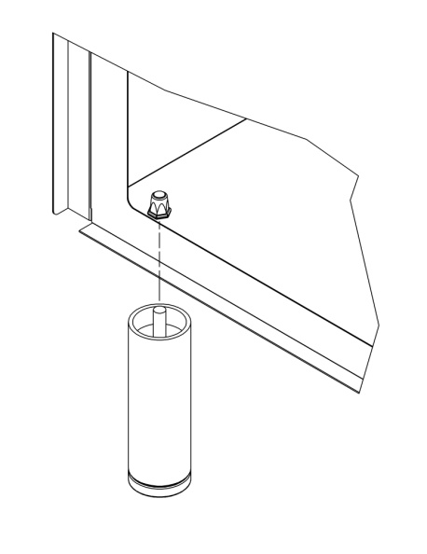

## 2.4. MINIMUM DISTANCE TO OBSTACLES

The machines expel hot air through the grilles, which must be discharged into the room and not accumulate. This is particularly important for the air expelled from the rear of the machines: a space of at least 10cm must be left up to the wall, allowing the air to flow from behind and out so that there is a renewal of this, avoiding the formation of hot air pockets in that area that could reduce the machine's ice production and even activate its protection against excessive temperature and stopping it.

**Connection diagram:**

The location should allow sufficient clearance for water drainage and electrical connections at the rear of the ice machine.

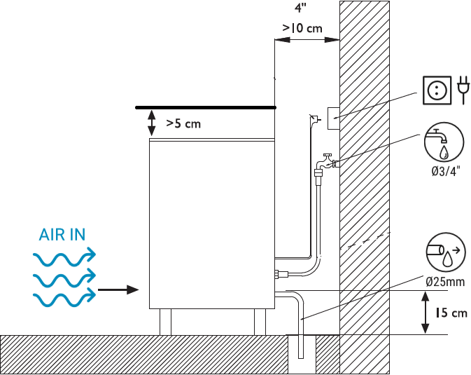

## 2.5. WATER SUPPLY CONNECTION

The quality of the water supplied to the ice maker will influence the time between cleanings and ultimately the life of the product (mainly on water-cooled units). It will also have a notable influence on the appearance, hardness and flavor of the ice.

Local water conditions may require water treatment to inhibit scale formation and improve flavor and clarity. If you are installing a water filtration system, refer to the installation instructions supplied with the filtration system.

The pressure must be between 0.1MPa and 0.6MPa (1 and 6 bar). If the pressure exceeds these values, install a pressure regulator.

In all ECO models the water connection(s) (2 connections) must be dedicated, i.e. there must be only one unit connected to the water line.

**ATTENTION:** The machine must be connected to the pipeline with adequate backflow protection in accordance with current national and local regulations.

## 2.6. DRAIN CONNECTION

### 2.6.1. GRAVITY DRAINAGE

The drain must be located lower than the level of the machine, at least 150mm.

It is advisable that the drain hose be 30mm in inner diameter and with a minimum slope of 3cm/meter.

  



### 2.6.2. DRAIN FORCE CONNECTION

This version of drain force allows an installation of the machine where the drain can be located 30 meters horizontally and 1.5 meters high from the machine's water outlet.

If the drain pipe runs incorrectly, the pump may not be able to drain the water, because the flow of the pump may be influenced due to the existence of stored air within the circuit.

## 2.7. ELECTRIC CONNECTION

* It is mandatory to connect the equipment to ground. To avoid possible electric shock to persons or damage to the equipment, the machine must be grounded in accordance with local and/or national regulations, as applicable.
* The manufacturer disclaims any responsibility in the event that damage occurs due to the lack of ground installation.
* The positioning of the appliance must ensure that the electrical supply is not damaged or choked.
* Do not install portable multiple sockets or other portable power sources on the rear of the appliance.
* The machine is supplied with a 1.5 m long cable.
* If the power cable is damaged, it must be replaced with a special mounting cable that will be supplied by the manufacturer or by the after-sales service. This replacement must be carried out only by a qualified technical service.
* The machine should be positioned so that there is a minimum of space between the back and the wall to allow easy and safe access to the cord plug.
* It is advisable to install a remote switch to completely disconnect the machine.
* Protect the outlet. Install appropriate switches, fuses and differential protector.

**ATENCIÓN:** El aparato requiere una fuente de alimentación independiente de capacidad adecuada. Consulte las especificaciones eléctricas en la placa de características. Si no se utiliza una fuente de alimentación independiente de la capacidad adecuada puede haber daños en los componentes internos o en el cableado. Esto podría provocar la generación de calor o un incendio.

The voltage is indicated on the nameplate and in the technical specifications section of this manual. A voltage variation greater than 10% indicated on the nameplate may cause damage or prevent the machine from starting.

1. ***PRIOR CONTROL AND START-UP***

## 3.1. PRIOR CHECK

1. Is the machine leveled?
2. Do the voltage and frequency match those on the nameplate?
3. Are the drains connected and working?
4. Are the ambient temperature and water temperature maintained in the following range?

|  |  |  |
| --- | --- | --- |
|  | **ATMOSPHERE** | **WATER** |
| *MAXIMUM* | 43ºC/109.4ºF | 35ºC/95ºF |
| *MINIMUM* | 10ºC/50.0ºF | 5ºC/41ºF |

1. Is the water pressure adequate?

|  |  |
| --- | --- |
| *MINIMUM* | 0.1MPa (1 bar) |
| *MAXIMUM* | 0.6 MPa (6 bar) |

**NOTE:** In case the inlet water pressure is greater than 6 bar, install a pressure reducer.

## 3.2. START UP

Once installation instructions have been followed (ventilation, site conditions, temperatures, water quality, etc.), proceed as follows:

1. Open the water inlet. Verify the no existence of leakages.
2. Open the door and remove the protection elements on the curtain.
3. Verify that the curtain moves freely.
4. Connect the machine to the power supply.
5. Push the switch on the machine front side.
6. Verify that there are no vibrations or frictions on the elements.
7. Close the door
8. Check the cubes after two cycles; they should be uniform in shape. If they do not come out correctly, or the unit does not make ice, contact an authorized service technician.

1. The unit produces ice until the bin is full, using a stop sensor. When the ice is removed from the bin, the unit will once again produce ice.

**WARNING:** this switch does not disconnect all the voltage inside the machine. Disconnect from the mains before handling.

# COMPONENTS DESCRIPTION

## 4.1 REFRIGERATION DIAGRAM

*Esquema frigorífico de condensación por aire*

It consists of the following components:

1. **Compressor:** It sucks in gases at low pressure from the cold source and supplies them with pressure and temperature to be discharged to the hot source.
2. **Condenser:** receives the gases from the compressor where they give up heat to the mean (air or water).
3. **Evaporator:** An evaporator that receives the refrigerant still with liquefied particles where they evaporate by absorbing heat from the mean. It is an isobaric and isothermal process.
4. **Capillar**
5. **Hot gas valve:** is a valve that is installed between the compressor discharge line (high pressure hot gas) and the low pressure line.
6. **Drier:** filters and dehydrates the coolant.
7. **Safety pressure switch** (high pressure): Stops the machine, in case a pressure higher than this value is reached:

R290 🡪 OFF 25 bar (362 psi)

1. **Condensing pressure switch**: Controls the fan (air condensation) or valve (water condensation) to keep the high pressure at the stipulated level:

R290 🡪 OFF11.5 - ON13.5 bar (167- 196 psi).

## 4.2 HYDRAULIC EQUIPMENT

* **Water inlet valve.** Controlled by the control board; supplies water to the tank.
* **Pump🡪** Hydraulic machine that sets water in motion, providing flow and pressure. They have a rotor with blades inside a casing and an electric motor that drives them. They can be submerged or aerial.
* **Injectors:** These are the terminal orifices that project the water into the moulds of the horizontal evaporators. They can be sprayers or flat showers.
* **Distributors:** Sets of injectors arranged inserted in a duct. Aligned and spaced with the "pitch" of the evaporator to which they spray.

## 4.3 ELECTRICAL EQUIPMENT

Compressor

Temperature probe

Water inlet solenoid valve

Condensation water inlet solenoid valve

Condensing pressure swicth

Electronic board

Switch exterior

Safety pressure switch

* **Switch exterior🡪**Can disconnect the power supply to the equipment or a point in the control system that guarantees the disconnection of the electrical elements.
* **Electronic board (PCB control)** 🡪 Control board that receives input signals, manages them and returns outputs, normally by activating relays.
* **Water inlet solenoid valve (EW)** 🡪 Input fresh water for the ney cycle.
* **Condensation water inlet solenoid valve (EW)🡪**Provides the water inlet for use in the condenser (ONLY ON WATER CONDENSED MACHINES).
* **Safety pressure switch (Pt)🡪** In the event of reaching the set pressure (25 bar), it stops the machine completely and sets it in alarm.
* **Condensing pressure swicth (Pc) 🡪** Starts or stops the fan or water inlet to maintain the set high pressure.
* **Temperature probe🡪**Temperature probe types are sensors that measure the temperature of a medium by converting a physical quantity into an electrical signal.
* **Compressor 🡪** It sucks in gases at low pressure from the cold source and supplies them with pressure and temperature to be discharged to the hot source.

## 4.4. CONTROL BOARD

|  |  |
| --- | --- |
| **Symbol** | **Description** |
| SC | Cycle NTC probe |
| T1 | Stock thermostat |
| P | Water valve |
| Q | Hot gas valve |
| S | Compressor |
| B | Water pump |
| F | Condensing pressure swicth |
| R | Fan |
| K | Condensation valve (water-condensing only) |
| H | Thermal protector (water)/Safety pressure switch (air) |
| Ig | General switch |

### 4.4.1 PCB CONNECTIONS

|  |  |
| --- | --- |
| **Symbol** | **Description** |
| CN1 | Inputs: Stock thermostat and safety pressure switch connections |
| CN2 | Cycle NTC probe |
| CN3 | Outputs: Connections: Compressor, pump, e/W-valve, hot gas valve |

### LED SIGNALLING: INPUTS

Red LED color with active signal.

|  |  |
| --- | --- |
| **LED ON** | **Description** |
| LP | (H) Thermal protector (water condensed only) |
| LT | (T1) Stock thermostat |

### LED SIGNALLING: OUTPUTS

Orange LED color with active signal.

|  |  |
| --- | --- |
| **LED ON** | **Description** |
| K1 | (S+R) Compressor, fan |
| K2 | (B) water pump |
| K3 | (P) Valve/w |
| K4 | (Q) Hot gas valve |

### 4.4.4 SIGNALLING LEDs

#### The following tables describe the signals provided by the different LEDs on the control board.

#### 4.4.3.1 Input LEDs

#### The input LEDs are positioned next to each of their corresponding inputs. Orange LED color with active signal.

#### 4.4.3.2 Output LEDs

#### The output LEDs are positioned next to their corresponding relays. Orange LED color with active signal.

#### 4.4.3.3 Status LEDs. Normal work (fixed LEDs)

There are four additional orange LEDs that signals machine status (continuous):

|  |  |  |  |  |
| --- | --- | --- | --- | --- |
| **Continuous orange LED** | **LE1** | **LE2** | **LE3** | **LE4** |
| Start up delay | X |  |  |  |
| Harvest t<tg | X |  | X |  |
| Harvest >tg |  |  | X |  |
| Ice cycle T>Tc | X | X |  |  |
| Ice cycle T<Tc |  | X |  |  |
| Full bin |  |  |  | X |

#### 4.4.3.4 Status LEDs. Alarm (Flashing LEDs)

The following table defines the alarm states of the machine, which can be differentiated with the following flashing of the status LEDs:

|  |  |  |  |  |
| --- | --- | --- | --- | --- |
| **Flashing Orange LED** | **LE1** | **LE2** | **LE3** | **LE4** |
| Thermal protector / Safety pressure switch | X |  |  |  |
| Ice cycle timeout 60’ (T evaporator>Tc) |  | X |  |  |
| Harvest cycle timeout 5’  (T evaporator<Tg) |  |  | X |  |
| Faulty temperatura probe |  |  |  | X |

### 4.4.4 DIP SWITCHES SETTING

The following table describes the functionality of the micro-switches that the table has, that is, the work options that the combinations of these can provide:

|  |  |
| --- | --- |
| **DIP Switches** | **Descripción** |
| SW1 MICRO 8 | Tc - Evaporator temperature for timer start.  ON-12ºC–OFF -8ºC. |
| SW2 MICRO 1 | Determines the temperature at which the evaporator must be at for the start of the  harvest. Tg (Hot valve temperature).  ON+4ºC-OFF 0ºC. |
| SW2 MICRO 2 | Manual or automatic thermal protector reset (water condensed only).  ON = AUTO  OFF=MANUAL. |
| SW2 MICRO 3 | ON. Timeout alarms operation activated. |
| SW2 MICRO 4 | ON |
| SW3  BUTTON | Press the button to change the state of the machine cycle. Production – harvest/Harvest – Production.  Pressing the SW3 push button and changing the switch to position (I) will change the status of the machine to cleaning cycle. |

The following table shows the default intensity configuration in each of the possible combinations allowed by the switches on the control board:

|  |  |  |  |  |  |  |  |  |
| --- | --- | --- | --- | --- | --- | --- | --- | --- |
| **SWITCH 1  (SW1)** | | | | **TF (MIN)** | **SWITCH 1 (SW1)** | | | **TW (SEG)** |
| **1** | **2** | **3** | **4** | **5** | **6** | **7** |
| OFF | OFF | OFF | OFF | 6 | OFF | OFF | OFF | 40 |
| ON | OFF | OFF | OFF | 8 | ON | OFF | OFF | 60 |
| OFF | ON | OFF | OFF | 10 | OFF | ON | OFF | 80 |
| ON | ON | OFF | OFF | 12 | ON | ON | OFF | 100 |
| OFF | OFF | ON | OFF | 14 | OFF | OFF | ON | 120 |
| ON | OFF | ON | OFF | 16 | ON | OFF | ON | 140 |
| OFF | ON | ON | OFF | 18 | OFF | ON | ON | 160 |
| ON | ON | ON | OFF | 20 | ON | ON | ON | 180 |
| OFF | OFF | OFF | ON | 22 |  |  |  |  |
| ON | OFF | OFF | ON | 24 |  |  |  |  |
| OFF | ON | OFF | ON | 26 |  |  |  |  |
| ON | ON | OFF | ON | 28 |  |  |  |  |
| OFF | OFF | ON | ON | 30 |  |  |  |  |
| ON | OFF | ON | ON | 32 |  |  |  |  |
| OFF | ON | ON | ON | 34 |  |  |  |  |
| ON | ON | ON | ON | 36 |  |  |  | The factory default will be indicated on the machine's wiring diagram, located on the cover of the electrical panel. |

### 4.4.5 FUNCTIONS OF THE INTERNAL BUTTON ON THE PCB

Function depends on the unit status:

* Start up timer: Finish initial delay y passes to ice production stage
* Ice production. Switches to harvest
* Harvest. Switches to Ice production

***Wash cycle activation***

Keep pressed the button while switching on main front switch. Wash cycle is activated and only the water recirculation pump is running. There is a maximum time for this cycle of 30 min. After this time, pump stops.

Wash cycle is finished by switching off main power.

Read cleaning and sanitizing instructions for proper usage of this function.

### 4.4.6 DRAIN FORCE CONTROL BOARD

|  |  |
| --- | --- |
| **PCB connections** | |
| **Outputs** | |
| **B** | Water pump |
| **Inputs** | |
| **Lw** | Water Level Sensor |

**LED signalling**

There are two LEDs that signals machine status.

|  |  |  |
| --- | --- | --- |
| **Status signaling. Continuous led** | **LED5** | **LED6** |
| **Pump running** | X |  |
| **Water level sensor on** |  | X |

# SEQUENCE OF OPERATION

Once you connect the machine there is a time delay of 140” during which the water valve is activated to ensure the water tray is filled. Compressor, pump will be off.

Once the time is up, it continues with a harvest cycle and the compressor starts.

After the harvest, the ice production starts, so the pump starts working. The pump, recirculates the water from the water tray to the upper nozzles (#2) distributor which provides a fan of water that waters each ice cube row in the evaporator (#1), in which the water starts freezing and making the ice.

When the temperature probe (#3) at the end of the evaporator reaches an adjusted value Tc (-12/-8°C) , the fabrication continues the fixed time with the combination of dip-switches 1-4 (see table). This way we can ensure the filling of the ICE CUBE is correct in different working conditions.

Once the production time is over the harvest phase starts. The pump stops, the hot gas and the water inlet valves open. When the evaporator temperature probe (#3) reaches an adjusted value Tg (4/0°C) the harvest continues the fixed time with the combination of dip-switches 5-7 (see table). Water is poured over the evaporator helping unstick the ice cubes from the plastic frame.

After the harvest cycle, the machine comes back to the production cycle.

At the beginning of each Harvest cycle, the PCB checks if the Thermostat is open or close. Once the ice bin is full and the ice cubes cover the thermostat tube (#4), the contact open, so when the harvest begins, the machine will stop until the contact of the thermostat close again. When it close, it starts with a harvest cycle and then it will continue with the production cycle again.

## 5.1.- SEQUENCE OF OPERATION

While the machine is turn on, there is water that need to be evacuated between each cycle. There are 2 possible outlet water, one is if the ice in the storage bin melts (#1) and the other is when the production time ends, the water electrovalve opens and fills the water tray(#2) to renovate the water. The excess of water goes out by the overflow (#3) to the drain force water reservoir (#4).

When the water reservoir is full of water covering the 2 electrodes (#5), the pump (#6) turns on and evacuates water for 5 seconds. After 5 seconds, the pump turns off if the electrodes are not covered by the water, otherwise, the pump will start again for 5 seconds.

In case that the system does not work for any issue, the water will flood the ice bin. There is a ventilation tube (#7) that allows the system to remove any air that may remain in the water reservoir. The Vent tube must be always over the mouth of the front door (#8).

In case that the pump works for 5 min continuously, it will stop for 5 seconds automatically in order to refrigerate.

The system has a way to evacuate the water inside the water reservoir in a manual way. There is a plug(#9) in one of the plastic tube, by retiring this plug, it is possible to evacuate all the water.

Also, the system has a Check valve(#10) that does not allow the water to came back to the water reservoir.

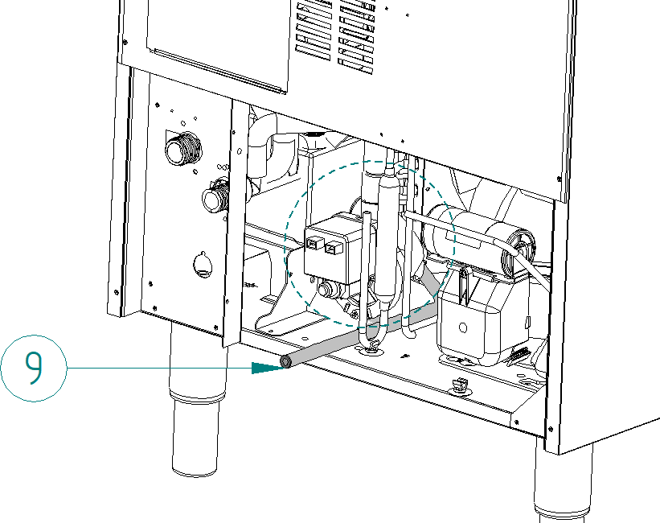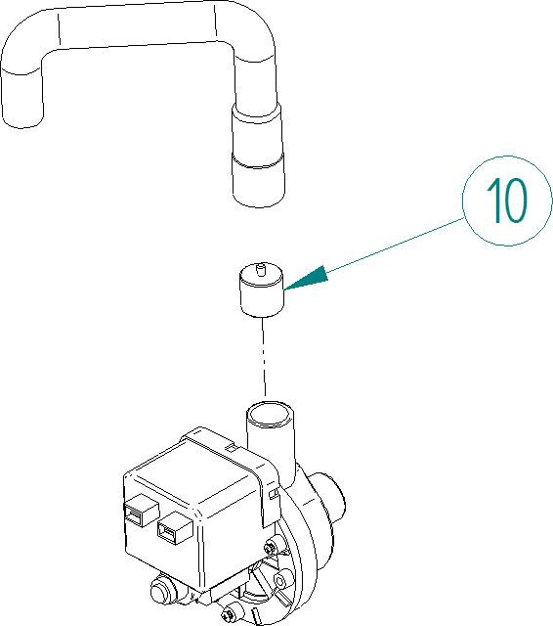

# 6- ALARMS

They detect operational malfunctions. They are indicated with the flashing status Leds LE1-4.

During some alarms a second operation retry attempt is carried out and if repeated again, the machine will stop. Signaling should be indicated since the first failure occurs. If the second retry attempt is ok, the signaling will switch off.

In case that a machine stop has been caused by alarm, the reset is done by switching OFF and ON the main switch. If the dip-switch 11 OFF, time alarms are not to be followed.

## 6.1 SAFETY HIGH PRESSURE SWITCH / THERMAL PROTECTOR

When the pressure contact (P) trips, instantly, all outputs switch over to off position.

When it is closed again, there are two possibilities:

* Dip-switch 10 OFF. Manual reset. The machine remains stopped until reset to Initial start-up.
* Dip-switch 10 ON. Automatic reset. The machine check pressure switch status every 30 min. When closed, the machine will continue at the position where it was.

*Signalling:* Flashing LE1.

## 6.2 LONG HARVEST

If the harvest time is longer than 5 min., the harvest is interrupted, switching over to the production cycle. If the same happens again at the next harvest, the machine will stop.

*Signalling:* Flashing in LE3.

## 6.3 ICE PRODUCTION CYCLE TIMEOUT

If during the production cycle, evaporator temperature probe has not reached the set temperature Tc in more than 60 min, the machine will stop until reset.

*Signalling:* Flashing in LE2.

## 6.4. FAULTY TEMPERATURE PROBE

If PCB detects that evaporator temperature probe is broken or unconnected, the machine will stop.

*Signalling:* Flashing in LE4.

Probe type is NTC and resistance value must be 10kΩ at 25°C.

# 7. MAINTENANCE AND CLEANING PROCEDURES

It is the User’s responsibility to keep the ice machine and ice storage bin in a sanitary condition.

Ice machines also require occasional cleaning of their water systems with a specifically designed chemical. These chemical dissolves mineral build up that forms during the ice making process.

Sanitize the ice storage bin as frequently as local health codes require, and every time the ice machine is cleaned and sanitized.

The ice machine’s water system should be cleaned and sanitized at least twice a year.

**CAUTION:** Do not mix Ice Machine Cleaner and Sanitizer solutions together.

**WARNING:** Wear rubber gloves and safety goggles when handling Ice Machine Cleaner or Sanitizer.

**WARNING:** Unit should always be disconnected during maintenance/cleaning procedures.

**RUBBER GLOVES AND SAFETY GOGGLES SHOULD BE WORN WHEN HANDLING ICE MACHINE CLEANER OR SANITIZER.**

## 7.1 CLEANING OF AIR CONDENSER

1. Disconnect the power supply of the machine.
2. Close the water inlet valve or the faucet.
3. Remove the front grid by removing the two screws placed at front side (see figure).

**Front grid**

1. Clean condenser using a vacuum cleaner, soft brush or low pressure air. Clean from top to bottom, not side to side. Be careful not to bend the fins of the condenser.
2. Open the water inlet valve or tap.
3. Switch on the power supply to the machine.

## 7.2 CLEANING THE WATER CONDENSER

1. Disconnect the machine.
2. Disconnect the water inlet or close the faucet.
3. Disconnect the water inlet and outlet from the condenser.
4. Prepare a solution at the 50% of phosphoric acid and distilled or demineralized water.
5. Make the solution circulate through the condenser. (The solution is more effective if hot – between 35ºC [95ºF] and 40ºC [104ºF]).

## 7.3 CLEANING WATER DISTRIBUTOR AND INJECTORS

1) Remove the curtain (#4). (Take advantage to clean it with Calklin or some non-aggressive product, rinse, clean with bleach and rinse under the tap).

2) Remove the ice fall grill (#3). (Clean it just like the curtain).

3) PULL UP THE COLLECTOR (#1) (IT IS PRESSURE MOUNTED)

4) Remove the nozzles (#3) and the manifold covers, clean them.

5) Remove and clean the main suction filter (#5) of the pump. (IT IS PRESSURE MOUNTED)Montar el filtro, los inyectores y el collector.

6) Fit filter, injectors, and collector.

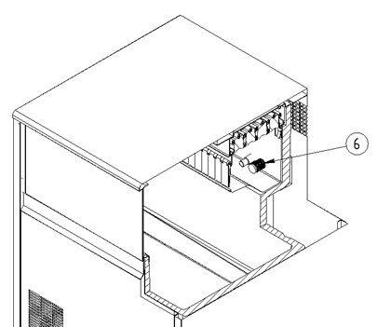

**ATTENTION:** IT IS VERY IMPORTANT, WHEN REPLACING THE MANIFOLD THAT THE INJECTORS ARE COMPLETELY PERPENDICULAR TO THE SAME. IF THE CUBES AT THE END ARE TWISTED, THEY CAN REMAIN WITHOUT WATER.

## 7.4 CLEANING THE ICE BIN AND EXTERIOR

1. Disconnect the machine, close water faucet and empty storage bin of ice.
2. Use the cleaner/water solution to clean all surfaces of the bin. Use a nylon brush or cloth. Then rinse all areas thoroughly with clean water.
3. Use the sanitizer/water solution to sanitize all surfaces of the bin. Use a nylon brush or cloth.
4. Rinse with plenty of water, dry, run the machine and open water faucet.

## 7.5 WATER LEAKAGE CHECKING

This must be done whenever maintenance is carried out on the machine: check all water connections, braces, tubes and hoses in order to eliminate leaks and prevent breakages and flooding.

## 7.6 CLEANING THE HYDRAULIC SYSTEM

1. Set the switch to the OFF position after ice falls from the evaporator at the end of a harvest cycle or set the switch to the OFF position and allow the ice to melt off the evaporator.

**CAUTION:** Never use anything to force ice from the evaporator.

1. Remove all ice from the bin.
2. Remove the water overflow (#1) and empty the water tray (#2). Return it to their original position to avoid water spill.

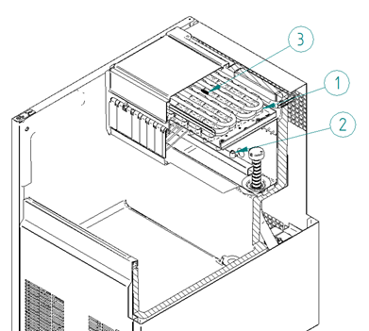

1. Prepare a solution of an appropriate product for the cleaning of ice machines (lime). Do not use hydrochloric acid. We recommend the use of any approved scale removal product prepared according to the manufacturer’s instructions as for example Calkin.
2. Fill water tray with the solution
3. Disconnect power
4. Turn on the machine pushing SW3 (see picture). Let solution stand for 30-40 minutes and then switch off the machine. Disconnect power

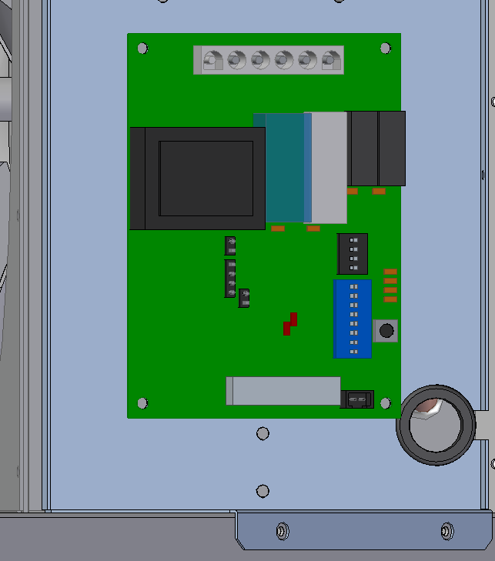

1. Remove the drain pipe to drain and purge out the ice machine scale remover and residue. Replace it.
2. Mix enough cleaning solution to clean parts and interior food zone surfaces.
3. Clean all surfaces of the shield with the cleaner solution using a brush (not a wire brush) or cloth. Rinse all areas with water.
4. Clean all the interior surfaces of the freezing compartment (including storage bin) with the cleaner solution using a brush or cloth. Rinse all areas with water.
5. Mix a disinfectant solution using a sanitizer approved for food equipment (following the manufacturer's instructions for use).
6. Sanitize all the interior surfaces of the freezing compartment (including the storage bin) applying liberally sanitizer solution, using a cloth or sponge.
7. Connect power and water supplies.
8. Fill water reservoir with the sanitizer solution.
9. Switch on machine in order to run water pump. Let solution stand for 20 minutes and switch off.
10. Remove the auxiliary cap to drain and purge out the sanitizer solution and residue. Replace it.
11. Fill the water reservoir with water and switch on the machine to allow water to circulate for 5 minutes and then stop the machine. Repeat this operation two more times to rinse thoroughly (by removing the cap to drain the water and replacing it for each cleaning cycle).
12. Return the back metal lid and the top panel to their position.
13. Switch on machine and discard the first two harvests.

## 7.7 MAINTEANCE TABLE

|  |  |  |  |  |  |  |
| --- | --- | --- | --- | --- | --- | --- |
| ACTION | MONTHLY | QUARTERLY | SEMESTERLY | ANNUAL | BIENNIAL | T UNIT |
| Cleaning air condenser |  |  |  |  |  | 30 minutes |
| Cleaning water condenser |  |  |  |  |  | 90 minutes |
| Inyectors cleaning |  |  |  |  |  | 45 minutes |
| Exterior and stock bin cleaning |  |  |  |  |  | 30 minutes |
| Cleaning hydraulic system |  |  |  |  |  | 30 minutes |
| General cleaning |  |  |  |  |  | -- |

|  |  |
| --- | --- |
|  | Depending on the characteristics of the environment |
|  | Indispensable/Essential |
|  | Depending on water quality |
|  | Performed by owner |

Maintenance and cleaning procedures, as well as problems resulting from their non-performance, **ARE NOT COVERED BY THE GUARANTEE.** Service personnel will bill you for travel expenses, time spent and materials required for maintenance and cleaning of the unit.

***8. TROUBLESHOOTING GUIDE***

## 8.1 GENERAL QUESTIONS

|  |  |  |
| --- | --- | --- |
| PROBLEMS | POSSIBLE CAUSES | SOLUTION |
| None of the electrical systems work. | No power | Check power supply and connection |
| Switch Interruptor OFF | Power on |
| None of the electrical systems work.  Front pilot is ON | Full bin status (LE4 on) with no ice.  Thermostat defective or incorrectly set | Check. Replace |
| PCB alarm. | Check the LED code |
| PCB ALARMS  See section 6 | | |
| Safety pressure switch | Dirty condenser | Clean condenser |
| Machine wrong located | Change machine location |
| Defective fan | Check. Replace |
| Water machine: Faulty water valve | Check. Replace |
| Defective safety / cooling switch | Check. Replace |
| NTC probe error | Defective probe | Check. Replace |
| Defective probe plug connection | Check. |
| Ice cycle timeout | No frozen evaporator | Check refrigeration system |
| NTC probe faulty contact | Check probe fitting |
| Faulty hot gas valve/coil | Check. Replace |
| Harvest cycle timeout | Harvest do not happen | Check water inlet strainer |
| Faulty hot gas valve/coil | Check. Replace |
| Wrong cycle sequence | DIP-Switch 2-4 OFF | Set ON |
| OTHER PROBLEMS | | |
| Compressor does not run, but voltage is supplied | Compressor/electrical equipment defective | Check/replace |
| Compressor runs, but does not cool | Refrigeration system not working properly | Check load and components |
| Plate is energized, but does not turn on | Internal board fuse open | Replace |
| Shutdown due to full store, but no ice | Failure of the stock thermostat | Replace |
| Thermostat NOK placement | Correct positioning |
| Abnormal noise in the machine | Fan or fan blades in bad condition or loose | Fix or substitute |
| Vibrating pipes or components | Reposition and/or fix |
| Noise in compressor | Substitute |
| White and partially formed cubes. | Dirty nozzles | Clean/Replace |
| Dirty suction filter | Clean/Replace |
| Lack of water at cycle´s end | Check water leaks |
| Too large cubes | Freezing time too large | Adjust by dip-switches 1-4 |
| Probe makes bad contact | Adjust by means of dip switches |
| Too small cubes | Freezing time too short | Adjust by dip-switches 1-4 |
| Dirty condenser | Clean |
| Faulty probe | Replace |
| Not all cubes are released | Harvest time too short | Adjust by dip-switches |
| Freezing time too large (Ice slab) | Adjust by dip-switches |
| Dirty evaporator | Clean |
| Faulty hot gas valve | Check / replace |
| Lack of water input | Check net pressure and input filters |
| Low ice production | Blocked condenser or air access to condenser | Clean condenser; improve air circulation |
| Faulty hot gas valve, doesn’t close totaly. | Replace |
| Low performance refrigeration system | Check |

## 8.2 PUMP DRAINAGE

|  |  |  |
| --- | --- | --- |
| PROBLEMAS | POSIBLES CAUSAS | SOLUCIÓN |
| The ice store is flooded | Check valve is blocked | Clean or replace it |
| The pump is broken | Replace pump |
| Electrodes do not detect water | Disassemble and clean, if problem persists, replace it |
| Drain pump starts and stops continuously | Check valve is open | Clean/Replace |
| Pump is always on | Electrodes detect water, even if there is none | Disassemble and clean electrodes, if problem persists, replace them |